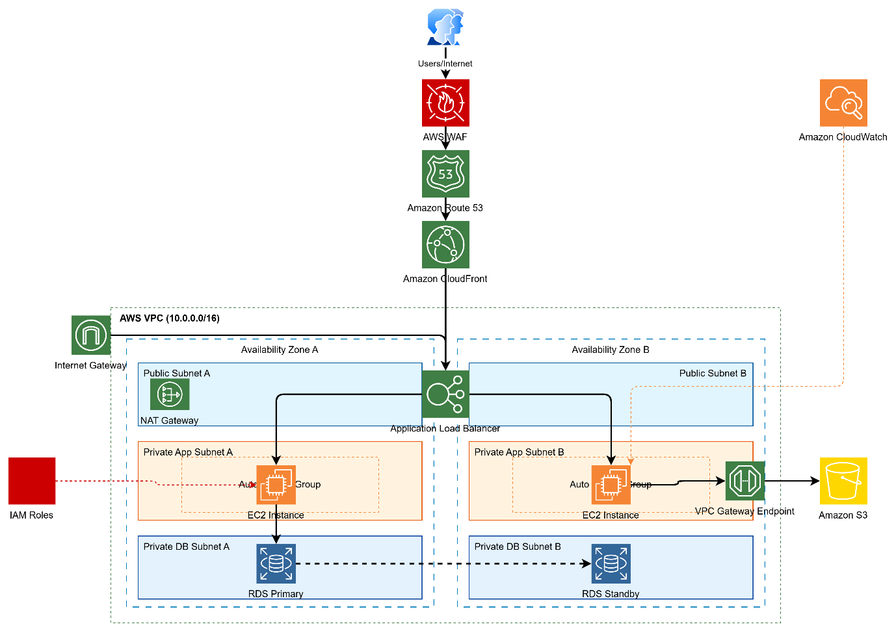

AWS Architecture – Step by Step Explanation
Step 1 — Users Access the Application
- Users access the application using a web browser or mobile app through the Internet.
- They enter the domain name (for example: www.myapp.com).
Users → Internet

Step 2 — AWS WAF (Web Application Firewall)
- The request first reaches AWS WAF.
- WAF protects the application from:
  - SQL Injection
  - Cross-Site Scripting (XSS)
  - DDoS attacks
  - Malicious bots
- Only valid and safe requests are allowed to move forward.
Users → AWS WAF
Purpose:
- Security Layer
- Blocks malicious traffic.

Step 3 — Amazon Route 53 (DNS Service)
- After WAF, the request goes to Amazon Route 53.
- Route 53 works as a DNS (Domain Name System).
It translates:
www.myapp.com
↓
CloudFront Distribution IP
Purpose:
- Domain name resolution
- High availability routing
WAF → Route 53

Step 4 — Amazon CloudFront (CDN)
- Route 53 forwards the request to CloudFront.
- CloudFront is a Content Delivery Network (CDN).
Functions:
- Delivers cached static content quickly
- Reduces latency
- Improves performance globally
Example cached content:
- Images
- CSS
- JavaScript
- Videos
If the content is not cached, CloudFront forwards the request to the Application Load Balancer (ALB).
Route 53 → CloudFront

Step 5 — Request Enters the AWS VPC
The request now enters the AWS Virtual Private Cloud (VPC).
VPC CIDR Block
10.0.0.0/16
VPC provides:
- Network isolation
- Security
- Control over subnets and routing
Inside VPC we have 2 Availability Zones:
Availability Zone A
Availability Zone B
This ensures High Availability and Fault Tolerance.

Networking Layer
Step 6 — Internet Gateway (IGW)
The VPC is connected to the internet using an Internet Gateway.
Purpose:
- Allows public subnets to communicate with the Internet
Internet → IGW → Public Subnets

Public Layer
Step 7 — Public Subnets
Two Public Subnets exist in two Availability Zones.
Public Subnet A
Public Subnet B
These subnets contain:
- Application Load Balancer
- NAT Gateway
Public subnets have:
- Internet access via IGW.

Step 8 — Application Load Balancer (ALB)
The request now reaches the Application Load Balancer.
ALB operates at:
Layer 7 (Application Layer)
Responsibilities:
- Distributes traffic across EC2 instances
- Improves availability
- Handles SSL termination
- Routes traffic based on rules
Example routing:
/api → EC2 Instance Group
/images → S3
Traffic is balanced between:
EC2 Instance AZ A
EC2 Instance AZ B
CloudFront → ALB

Application Layer
Step 9 — Private App Subnets
The application servers run in Private App Subnets.
Private App Subnet A
Private App Subnet B
These subnets do NOT have direct internet access.
Security advantage:
- Backend servers are hidden from the internet.

Step 10 — EC2 Instances in Auto Scaling Group
Inside the private subnets, we deploy EC2 instances.
They are managed using:
Auto Scaling Group
Auto Scaling features:

Automatically:
- Launch new instances when traffic increases
- Remove instances when traffic decreases
- Maintain minimum number of servers
Example:
Min Instances = 2
Desired = 4
Max = 10
This ensures:
- High availability
- Performance optimization

Storage Layer
Step 11 — Accessing Amazon S3 via VPC Endpoint
The EC2 instances need to access Amazon S3.
Instead of using the internet, we use a VPC Gateway Endpoint.
EC2 → VPC Gateway Endpoint → S3
Benefits:
- Traffic stays inside AWS network
- More secure
- Lower latency
- No internet required
S3 stores:
- Images
- Logs
- Backups
- Static files

Database Layer
Step 12 — Private Database Subnets
The database is placed in Private DB Subnets.
Private DB Subnet A
Private DB Subnet B
These subnets have NO internet access.

Step 13 — Amazon RDS Multi-AZ Deployment
Primary database:
RDS Primary
(AZ A)
Standby database:
RDS Standby
(AZ B)
Working:
Application → RDS Primary
Data is automatically replicated to standby.
If primary fails:
Automatic Failover → Standby becomes Primary
Benefits:
- High availability
- Disaster recovery
- Automatic failover

Security Layer
Step 14 — IAM Roles
IAM Roles provide secure permissions to services.
Example permissions:
EC2 → Access S3
EC2 → Send logs to CloudWatch

Benefits:
- No hardcoded credentials
- Secure access management

Monitoring Layer
Step 15 — Amazon CloudWatch
CloudWatch monitors the entire system.
It collects:
Metrics:
- CPU utilization
- Memory usage
- Network traffic
Logs:
- Application logs
- System logs
Alarms:
- High CPU alerts
- Auto scaling triggers
Example:
If CPU > 70%
→ Launch new EC2 instance

Final Request Flow (End-to-End)
Complete request flow:
User
↓
Internet
↓
AWS WAF
↓
Route 53
↓
CloudFront
↓
Application Load Balancer
↓
EC2 Auto Scaling Group
↓
RDS Database
Additional connections:
EC2 → S3 (via VPC Endpoint)
EC2 → CloudWatch (Monitoring)
IAM → Permission Management

Key Architecture Benefits
High Availability
- Multi-AZ deployment
- Load balancing
- Auto Scaling
Security
- AWS WAF
- Private subnets
- IAM roles
- VPC endpoints
Performance
- CloudFront CDN
- Auto Scaling
- Load Balancer
Cost Optimization
- Auto scaling reduces unused resources
- S3 low-cost storage

